
Nursery Newsletter - Welcome to Our New Term!

A Warm Welcome to All Our New Families
We would like to give a very warm welcome to all our new children and families joining Nursery this term and to our returning children and families too. We are looking forward to getting to know you all and supporting your child as they begin their exciting learning journey with us in the Caterpillar Class, here at St Faith’s C.E. Infant and Nursery School.

Settling In
Our first weeks will focus on helping children settle into Nursery, learn routines, make friendships, explore resources and develop confidence through play.

All About Me
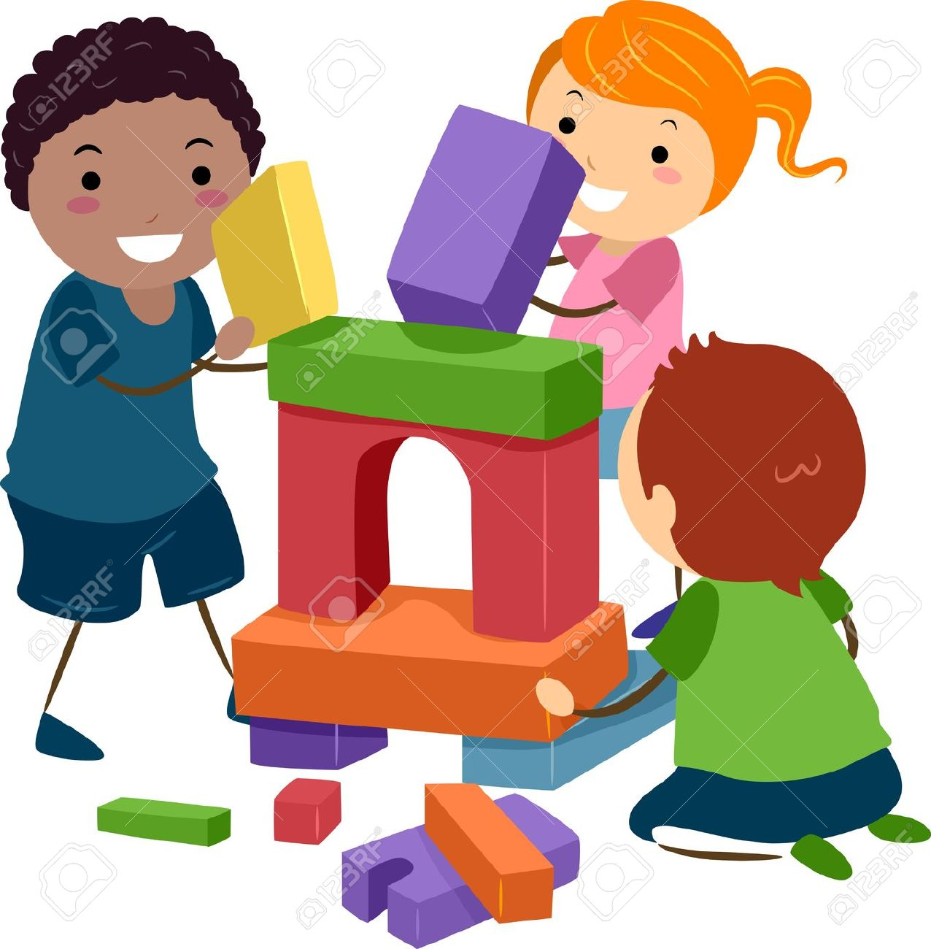
The children will begin their journey in school, learning how to play with other children, how to talk about the people that are special to them and to build confidence with the key people in their daily lives in school. Please ensure scrapbooks are completed and returned by 14th September. We will share them with the children as we learn about ourselves, our families,our favourite activities and special memories.

My Amazing Body

We will learn about body parts through stories, songs and activities. Children will also learn good hygiene routines, including washing hands after using the toilet and before lunch.

Families and People Who Care for Us
We will celebrate different family structures, learn about similarities and differences, and develop a sense of belonging within our Nursery community.

Outdoor Learning Reminder


Please provide named wellies and named waterproof over-trousers. Waterproof over-trousers are preferred to puddle suits as they encourage independence.

Important Nursery Reminders
All clothing and belongings must be clearly labelled.
No toys from home.
Packed lunches must be nut-free and should not contain sweets or chocolate. Please provide a balanced lunch that your child will eat. This is only necessary if you are not booking with Good Lookin Cookin.
All children need a named water bottle – this should be an easy open sports cap, not a screw lid open neck bottle.

The School Day
As a reminder, school starts at 9am – the door will open just before 9 to allow for a steady flow of children in, we ask that you leave your child at the door as there are plenty of adults to help the children organise themselves in the classroom.
If you are collecting at lunch, pick up is at 12pm – we ask that you are prompt for collection and if you are going to be a few minutes late to let the office know. For those leaving after a morning session, a small snack to eat while they wait helps to keep them going before they get home for their lunch (this could be some crackers and cheese, or a small sandwich, or some fruit – they have about 15 minutes to eat before their session finishes) Afternoon sessions start at 12pm, please allow those leaving the morning session first. Children starting in the afternoon will arrive at school having already had their lunch at home.
The end of the day is 3pm. If you are wishing for your child to stay until 3:30pm, this needs to be booked in advance, this is a separate session to Fireflies, therefore if you wish for them to also attend Fireflies (which starts at 3:30pm) you will need to make two bookings. A member of staff will take any children attending Fireflies to the hall.
We do ask that you are prompt with drop off and pick up as children can become upset if they are not collected on time.

Dates to Remember
14th September: Jeans for Genes Day and Scrapbooks Due
23rd September: Individual Photo Day
25th September: Plesiosaur Day
7th October: Grandparents Coffee Afternoon
Week Beginning 12th October: Feel Fabulous Friday
14th October: Family Progress Meetings (more information to follow)
16th October: Harvest Festival

