Nursery Medium Term Planning Autumn 1
Value – Friendship

Key experiences this term

Key vocabulary this term
Week 1 and 2

Week 3 and 4

Week 5 and 6

Week 7 and 8

Development Matters/ Birth to Five Matters links
PSED
Communication and Language
Physical Development
Literacy
Maths- SSM
Understanding the World
Expressive Arts and Design

 | Week 1 W/c 30th August  (2 days) | Week 2 – 7th September | Week 3 – 14th September | Week 4 –  21st September | Week 5 – 28th September | Week 6- 5th October | Week 7- 12th October |  | Week 8- 19th October
Theme | Settling in |  | All About Me |  | Our Bodies and Harvest |  |  | Our families
Focus text | 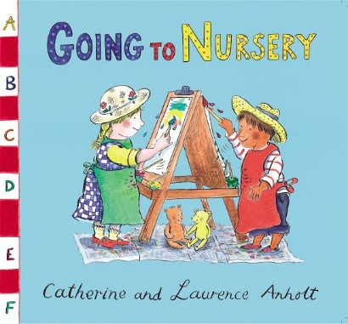 |  | Children’s Scrap books | 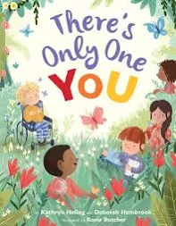 | 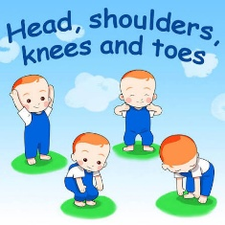 | 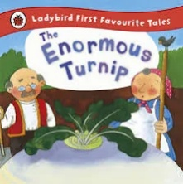 |  | 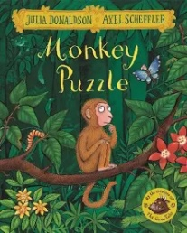 | 
CLL
PSED
PD
L
M
UW
EAD
Indoor Enhanced Provision
Outdoor enhance provision
Data

